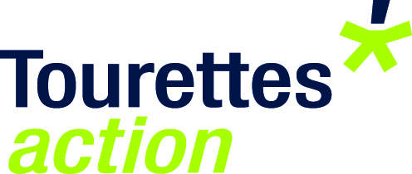

Application for non-financial support for researchers

We offer non-financial support to researchers wishing to recruit people for their research studies. Please contact TA Research Manager, Seonaid Anderson to discuss ways we can help to publicise your research project.
Please note that you will need to have ethical approval for your study in order for us to support you. Please download and read TA’s conditions for non-financial support before you contact us to make sure that your project meets the criteria.

- Details of principal applicant
Name: Full title, all initials and surname
Institution
Present position of Applicant
Contact address
Telephone
E-mail
Details of supervisors
Supervisors names
Institutions
Contact address
Telephone
E-mail
- Title of project

- Length of project (in months)

Please attach a Gannt chart/timeline to your application showing milestones e.g. ethical approval, advertising for participants, data collection, write up, when Tourettes Action can expect a written report on your findings, when data will be published or presented at conference. Also dates of monthly email updates to TA’s research manager should be incorporated.
- Briefly describe the aims of this project using non-technical terminology and describe how this project fits the remit of Tourettes Action. Please note that this section may be seen by non-scientists.
5. Outline your proposed research plan. You should describe the hypothesis to be tested and the methods of research to be used. The study design should be described in sufficient detail for our advisors to understand what is proposed. Please be clear about the method of recruitment.

6. Please write a short literature review with justification for why Tourettes Action should support your research

7. Please give evidence of how the proposed research will improve the lives or impact on people with TS?

8. Please give the names of journals/conferences you would anticipate publishing/presenting this research (this should also be included in your Gantt chart).

Please name the files with the principal applicant’s surname (for example smithoutline.doc) and return this form by e-mail to: Seonaid@tourettes-action.org.uk

A condition of receiving non-financial support from Tourettes Action is that you agree or provide the following:
CHECKLIST
I will give feedback of results/reports to Tourettes Action

I will give acknowledgement to Tourettes Action in any published papers and or conference presentations/posters.
I will place the TA logo on all information sheets and documents
I am willing to liaise with Tourettes Action in order to help raise awareness of research (e.g. completing Spotlight on researchers profile, feedback about the research findings)
I will signpost my participants to fill in feedback about their experience as a research participant on the Tourettes Action website https://www.surveymonkey.com/s/ZDNH9VH
I have attached the following copies to this application form:

A Gantt chart of the study
the CV of the PI;
a copy of the Ethics Committee's approval of the study;
a copy of the full Ethics Committee application
evidence of clear CRB checks taken within the past 3 years, from all research staff who will have contact with children and/or vulnerable adults and
a copy of the project proposal together with evidence of support from the Host
Institution
a copy of any participant information sheets, consent forms, questionnaires/interviews
an advert which could be used on the Tourettes Action website/newsletter if application for support is successful

